623. Add One Row to Tree
Medium

Given the root of a binary tree and two integers val and depth, add a row of nodes with value val at the given depth depth.
Note that the root node is at depth 1.
The adding rule is:
- Given the integer depth, for each not null tree node cur at the depth depth - 1, create two tree nodes with value val as cur's left subtree root and right subtree root.
- cur's original left subtree should be the left subtree of the new left subtree root.
- cur's original right subtree should be the right subtree of the new right subtree root.
- If depth == 1 that means there is no depth depth - 1 at all, then create a tree node with value val as the new root of the whole original tree, and the original tree is the new root's left subtree.

Example 1:
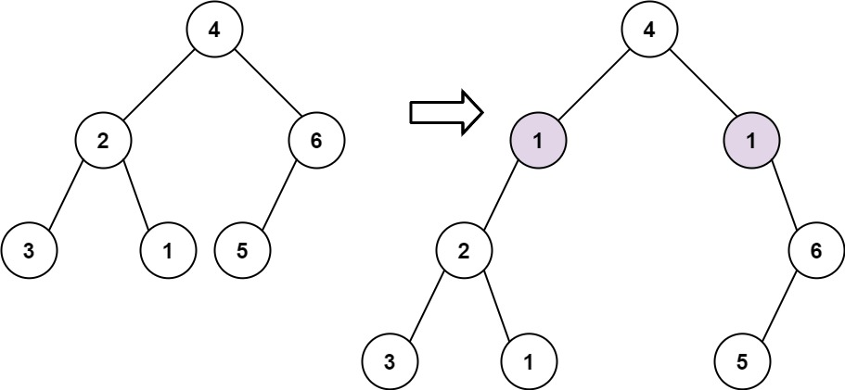
Input: root = [4,2,6,3,1,5], val = 1, depth = 2
Output: [4,1,1,2,null,null,6,3,1,5]
Example 2:
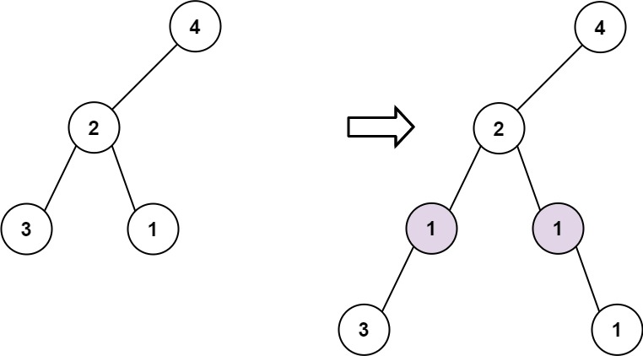
Input: root = [4,2,null,3,1], val = 1, depth = 3
Output: [4,2,null,1,1,3,null,null,1]

Constraints:
- The number of nodes in the tree is in the range [1, 104].
- The depth of the tree is in the range [1, 104].
- -100 <= Node.val <= 100
- -105 <= val <= 105
- 1 <= depth <= the depth of tree + 1

